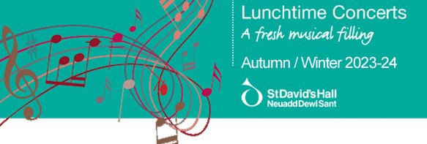

Tuesday 26 September — 1pm Charlotte Saluste-Bridoux, Violin & Joseph Havlat, Piano
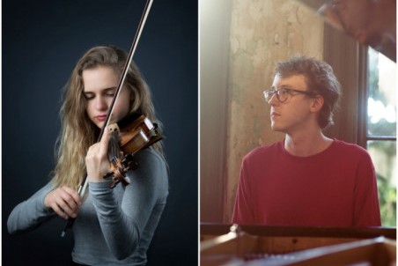

£6.50/(£5.50 concessions) when booked in advance.
£7.50/(£6.50 concessions) on the day of the concert.

Enescu Impromptu Concertant in G-flat major for Violin and Piano
Schubert Violin Sonata in A major, ‘Duo’
Ravel Violin Sonata No 2 in G major
Join us for a classical afternoon with Young Classical Artists Trust prize-winner Charlotte Saluste-Bridoux and pianist and composer, Joseph Havlat, as they perform works by Enescu, Schubert and Ravel.

Tuesday 3 October — 1pm
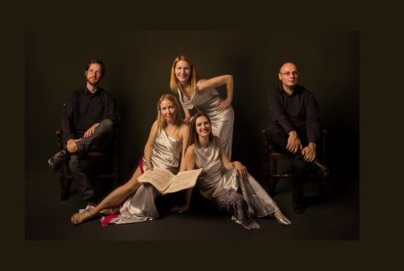

Galliard Ensemble

Ferenc Farkas Early Hungarian Dances: Intrada, Dance of Lázár Apor /
Apor Lázár tánca, Leaping dance/Ugrós
Franz Danzi Quintet in B-flat major, Op 56, No 1
Darius Milhaud La Cheminée du Roi René
Norman Hallam Dance Suite: Waltz, Bossa Nova & Charleston

Former BBC New Generation Artists, the Galliard Ensemble is established as one of Britain's leading chamber groups, with repertoire ranging from Mozart and Beethoven to Berio and Birtwistle.

Now in its 30th year, the ensemble has performed in many of the world’s leading
venues and festivals, including Wigmore Hall, South Bank Centre, Bridgewater Hall, Sage Gateshead and at the BBC Proms.

Gabriele Agrimonti, Organ
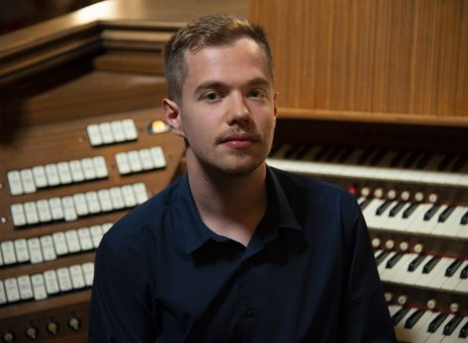

St Albans International Organ Festival
Winner Recital Concert

Vivaldi Concerto grosso in D minor, Op 3 No 11, RV 565
(organ transcription by Bach)
Bossi Fervore, Op 140, No 1
Verdi Requiem: Dies Irae, Lacrymosa, Libera Me (organ transcription by Agrimonti)
Agrimonti Improvisation

Born in 1995, Gabriele Agrimonti is an italian organist who currently lives in Paris. In 2022 he was appointed as the titular organist and Artistic Director of the historic J Merklin organ of France’s national church in Rome Saint-Louis-des-Français.

His musical education began at the age of 11 and in 2016 he graduated with a Master’s degree cum laude at the Parma conservatory with Mario Verdicchio.
At the age of 13 he was co-titular organist of the Basilica magistrale di Santa Maria della Steccata in Parma, introduced by the titular Ugo Leoni.
In association with Cardiff Organ Events.

Tuesday 14 November — 1pm
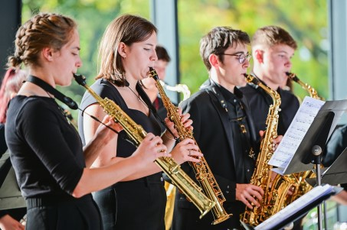

Royal Welsh College Saxophone Choir Directed by Gerard McChrystal

Nigel Wood Under the Veil
Girolamo Frescobaldi (arr David Flatt) Toccata
Gustav Holst (arr Robert Rainford) A Moorside Suite, III: March
Leonard Bernstein (arr Eddie Chung) Candide
Nigel Wood Stemming+ Stephen Bryant Dusk Nigel Wood Jab Jab
Arturo Marquez (arr K Veen) Danzón No 2 Jonathan Taylor Milonguita Para Muchos Saxofones Richard Ingham Mrs Malcolm, Her Reel

Join us for an exhilarating afternoon of saxophone music by the Royal Welsh College Saxophone Choir and directed by Professor Gerard McChrystal.
Debussy Cello Sonata
Nadia Boulanger Three Pieces for Cello and Piano
Webern Two Pieces
Franck Violin Sonata

Jâms Coleman and Alice Neary regularly appear at the major chamber music festivals in the UK and internationally. Here they join forces to perform a programme that explores music from the late nineteenth century and early twentieth century. Their programme culminates in a performance of Franck's well-loved Violin Sonata (which was originally intended for the cello).

From Anglesey, Jâms Coleman is a pianist who enjoys performing as a soloist, chamber musician, and vocal accompanist.
Alice Neary was a member of the Gould Piano Trio from 2001-2018, career highlights include the complete piano trios of Beethoven, Schubert and Dvořák at the Wigmore Hall, the commissioning of new works from Sir James MacMillan and Mark Simpson, regular tours of USA and over 25 CD releases.
Tuesday 28 November — 1pm . Cardiff Metropolitan Cathedral Choir with members of the Concert Orchestra from St John’s College
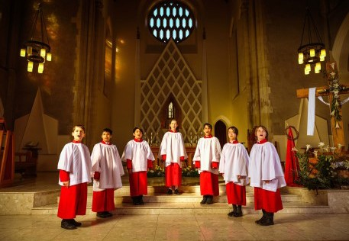

Directed by Jeffrey Howard

The Cathedral Choir begins our festive season with a beautiful selection of traditional carols and music for Christmas, with members of the Concert Orchestra from St John's College. Early booking advised.

Friday 1 December — 1pm .
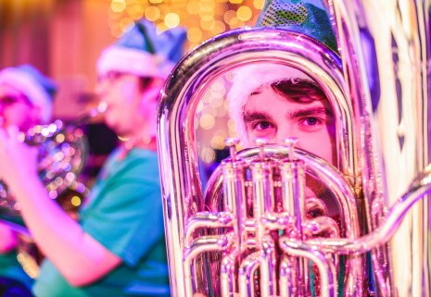

Royal Welsh College of Music & Drama Festive Brass
Directed by Dr Robert Childs

Royal Welsh College Brass Band, directed by Dr Robert Childs, presents its popular lunchtime concert of carols and festive favourites at St David’s Hall. The perfect chance for a family sing along and to embrace some Christmas cheer.
Beethoven Sonata in C minor Op 13 ‘Pathétique’
Debussy La plus que lente L128
Grainger Country Gardens
Debussy Préludes, Book 1 L125 IV: Les sons et les parfums tournent dans l’air du soir
Grainger Molly on the Shore
Debussy Préludes, Book 1 L125 : VIII: La fille aux cheveux de lin
Stravinsky (arr. Agosti) The Firebird Suite

Pianist Simon Callaghan begins his programmes with one of Beethoven’s most
celebrated sonatas, subtitled Grande sonate pathétique by his publishers. It is the first of Beethoven’s sonatas to begin with a slow introduction, setting the scene for a dramatic work, exploiting the potential of the piano of Beethoven’s day to its fullest.

The remainder of Callaghan’s programme showcases a colourful array of compositions from the first decade of the twentieth century, from Debussy’s exquisite preludes, Grainger’s folk-influenced miniatures, and concluding with Stravinsky’s Firebird Suite, in a virtuoso arrangement by Guido Agouti, dedicated to his teacher, the great pianist- composer, Ferruccio Busoni.
Tuesday 30 January — 1pm Jonathan Leibovitz, Clarinet & Joseph Havlat, Piano
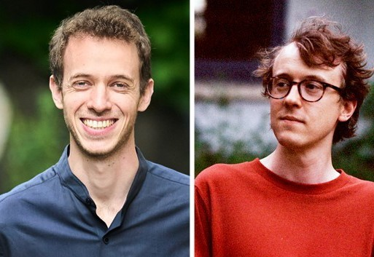

Weinberg Sonata for Clarinet and Piano, Op 28 Brahms Clarinet Sonata No 2 in E-flat major, Op 120 Poulenc Clarinet Sonata
In 2022 Jonathan Leibovitz was a prize-winner at the Young Classical Artists Trust (YCAT) and Concert Artists Guild (New York) International Auditions held at Wigmore Hall.
Joseph Havlat is a pianist and composer from Hobart, Australia, based in London. Working as a soloist and chamber musician for music very new, very old and some things in between, he has performed in major concert venues around the UK, Europe, America, Japan and Australia.


